**RIP Routing Configuration Using 3 Routers**

Routing Information Protocol (RIP) is an active routing protocol that operates hop count as a routing metric to find the most suitable route between the source and the destination network. It is a distance-vector routing protocol that has an AD value of 120 and works on the Network layer of the OSI model.

**Steps to Configure and Verify Three Router Connections in Cisco Packet Tracer using RIP Routing:**

**Step 1:** First, open the Cisco packet tracer desktop and select the devices given below:

| **S.NO** | **Device** | **Model Name** | **Qty.** |
| --- | --- | --- | --- |
| **1.** | PC | PC | 6 |
| **2.** | Switch | PT-Switch | 3 |
| **3.** | Router | PT-router | 3 |

**IP Addressing Table:**

| **S.NO** | **Device** | **IPv4 Address** | **Subnet mask** | **Default Gateway** |
| --- | --- | --- | --- | --- |
| **1.** | PC0 | 192.168.10.2 | 255.255.255.0 | 192.168.10.1 |
| **2.** | PC1 | 192.168.10.3 | 255.255.255.0 | 192.168.10.1 |
| **3.** | PC2 | 192.168.20.2 | 255.255.255.0 | 192.168.20.1 |
| **4.** | PC3 | 192.168.20.3 | 255.255.255.0 | 192.168.20.1 |
| **5.** | PC4 | 192.168.30.2 | 255.255.255.0 | 192.168.30.1 |
| **6.** | PC5 | 192.168.30.3 | 255.255.255.0 | 192.168.30.1 |

* Then, create a network topology as shown below the image.
* Use an Automatic connecting cable to connect the devices with others.

**Step 2:** Configure the PCs (hosts) with IPv4 address and Subnet Mask according to the IP addressing table given above.

* To assign an IP address in PC0, click on PC0.
* Then, go to desktop and then IP configuration and there you will IPv4 configuration.
* 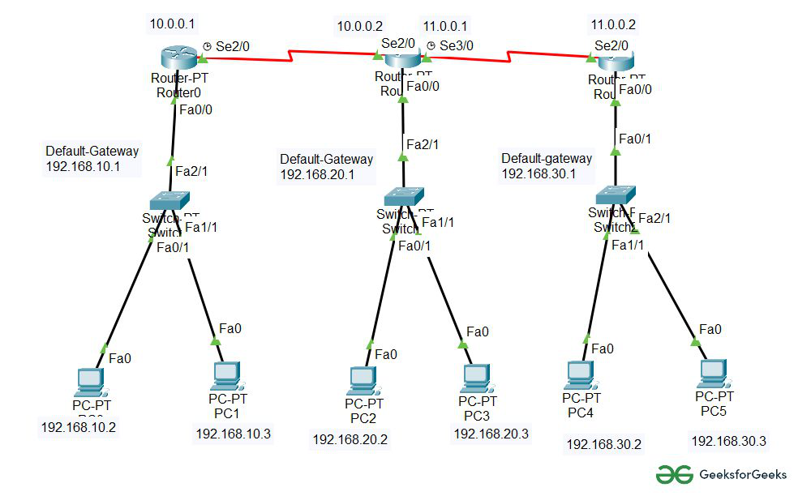Fill IPv4 address and subnet mask.

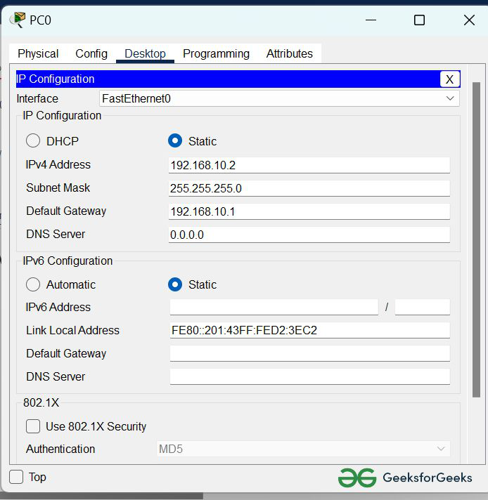

* Assigning an IP address using the ipconfig command, or we can also assign an IP address with the help of a command.
* Go to the command terminal of the PC.
* Then, type iPConfig <IPv4 address><subnet mask><default gateway>(if needed)

Example: iPConfig 192.168.10.2 255.255.255.0 192.168.10.1

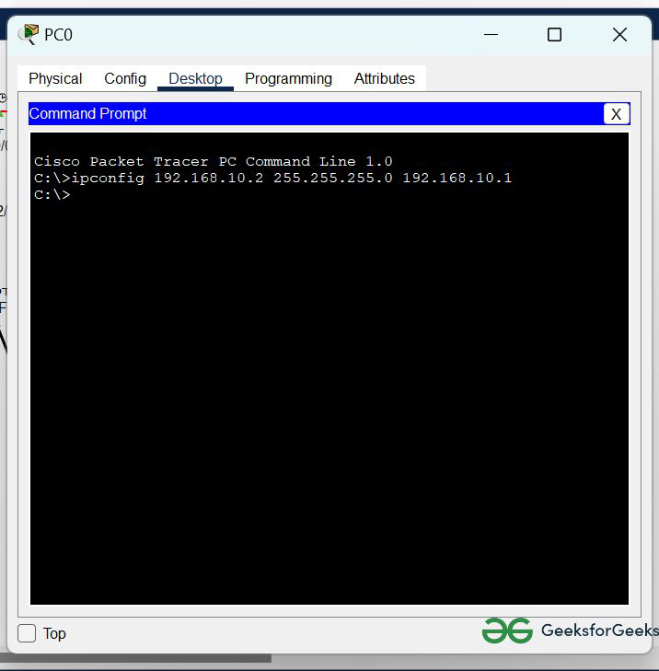

* Repeat the same procedure with other PCs to configure them thoroughly.

**Step 3:**Configure router with IP address and Subnet mask.

**IP Addressing Table Router:**

| **S.NO** | **Device** | **Interface** | **IPv4 Address** | **Subnet mask** |
| --- | --- | --- | --- | --- |
| **1.** | router0 | FastEthernet0/0 | 192.168.10.1 | 255.255.255.0 |
| Serial2/0 | 10.0.0.1 | 255.0.0.0 |
| **2.** | router1 | FastEthernet0/0 | 192.168.20.1 | 255.255.255.0 |
| Serial2/0 | 10.0.0.2 | 255.0.0.0 |
| Serial3/0 | 11.0.0.1 | 255.0.0.0 |
| **3.** | router2 | FastEthernet0/0 | 192.168.30.1 | 255.255.255.0 |
| Serial2/0 | 11.0.0.2 | 255.0.0.0 |

* To assign an IP address in router0, click on router0.
* Then, go to config and then Interfaces.
* Make sure to turn on the ports.
* Then, configure the IP address in FastEthernet and serial ports according to IP addressing Table.
* Fill IPv4 address and subnet mask.

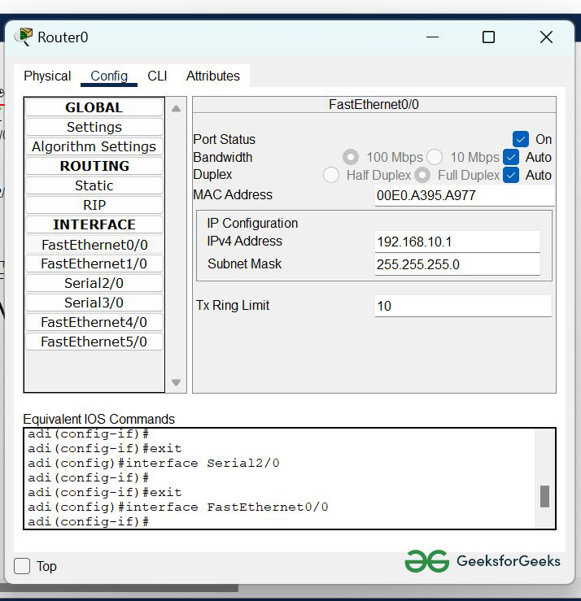

* Repeat the same procedure with other routers to configure them thoroughly.

**Step 4:** After configuring all of the devices we need to assign the routes to the routers.

To assign RIP routes to the particular router:

* First, click on router0 then Go to CLI.
* Then type the commands and IP information given below.

CLI command : network <network id>

RIP Routes for Router0 are given below:

Router(config)#network 192.168.10.0

Router(config)#network 10.0.0.0

RIP Routes for Router1 are given below:

Router(config)#network 192.168.20.0

Router(config)#network 10.0.0.0

Router(config)#network 11.0.0.0

RIP Routes for Router2 are given below:

Router(config)#network 192.168.30.0

Router(config)#network 11.0.0.0

**Step 5:**Verifying the network by pinging the IP address of any PC.

* We will use the ping command to do so.
* First, click on PC0 then Go to the command prompt.
* Then type ping <IP address of targeted node>.
* As we can see in the below image we are getting replies which means the connection is working properly.

Example : ping 192.168.20.2

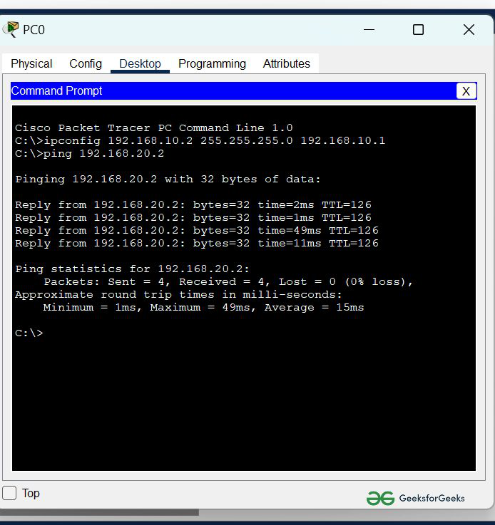

* A simulation of the experiment is given below we are sending PDU from  PC0 to PC2 and PC3 to PC5:

